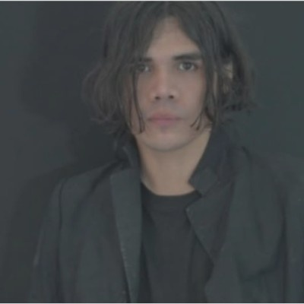  CONTACT  Mexico City  eme.nitf@gmail.com  www.ximn.nesfera.com  LANGUAGES  Spanish — Native  English — Intermediate / Advanced  CORE SKILLS  AI / Media Generation  – Use of multimodal models  – Prompt engineering and curation  – AI-driven narrative conceptualization  – Fine-tuning workflows (conceptual)  – Creative prototyping with AI  TECHNICAL COMPETENCIES  – Prompt creation and optimization  – Interaction with multimodal systems  – Efficient use of generative tools  – Computer vision applied to media  – Conceptual and narrative design  – Creative direction  – Curation of generative resources  EDUCATION  Professional Training in Applied AI  Centro Público de Inteligencia Artificial (Mexico)  AI fundamentals and applied methodologies; emphasis on creative workflows, digital media, and emerging technologies.  Status: Completed  Diploma in Artificial Intelligence  TCS — Tata Consultancy Services / Tecnológico Nacional de México  TCS AI Explorer program — 141 hours of structured training in Data Analysis, AI, and Employability. | MARTIN NOBLE  CREATIVE  SUMMARY  Creative specialized in AI-generated media, with three years of hands-on experience using multimodal models, computer vision tools, and workflows for AI-assisted audiovisual creation. Focused on developing new forms of visual language and production methodologies through emerging technologies.  XP  Creative Freelancer / Director Fiverr and independent — 2.5 years  ▪ Development of visual concepts, identities, and AI-assisted creative pieces for international clients (Fiverr Level 2).  ▪ Direction and production of music videos and commercial prototypes.  ▪ Hybrid workflows between AI and traditional editing.  ▪ Collaboration with artists, creators, and marketing teams.  PROJECTS AND CREATIVE WORK  ▪ AI-assisted music videos (50+ projects).  ▪ AI-driven commercial visuals for international companies.  ▪ Experimental short films and AI festivals.  ▪ Ongoing personal research in multimodal models.  EXHIBITIONS, PUBLICATIONS AND SCREENINGS  ▪ Participation in AI film festivals and contests: AI Reply Venice, AIFF Runway, Curious Refuge Film Contest, GEN:48.  ▪ Featured in Runway Watch with “Imagine City” (original film concept).  ▪ Author of the book AI ARTIST–: Images, Culture, and the Illusion of Reality.  COLLABORATIONS  Works with international companies, artists, and creators on visual production and generative storytelling.  Member of the creator programs at RunwayML and OpenArt, leading companies in generative artificial intelligence.

